WELCOME
34th ANNUAL GOLF CLASSIC
BREAKFAST OPTIMIST CLUB OF EAST FORT WORTH

PAYMENT GLADLY ACCEPTED IN THE FOLLOWING FORMS:
CASH
VENMO
CHECKS PAYABLE: BEFW OPTIMIST

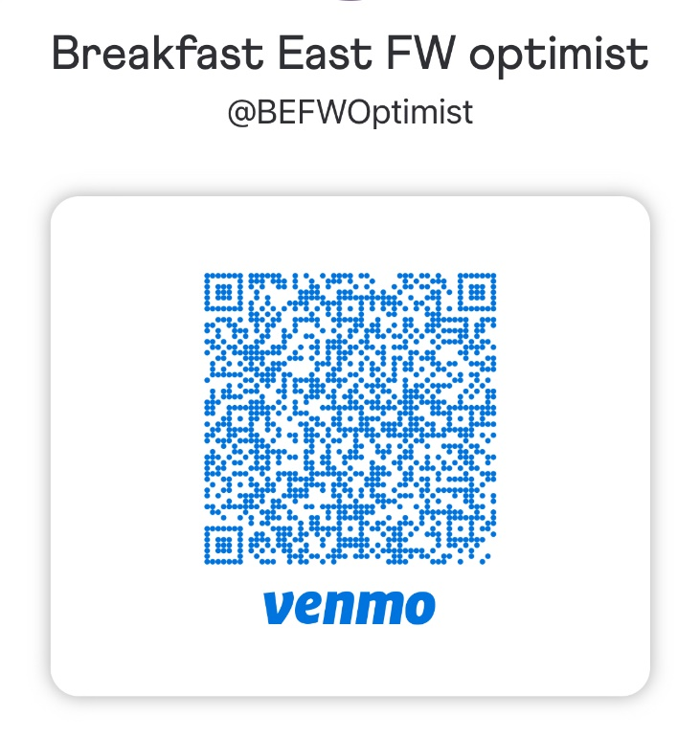

WE THANK YOU FOR YOUR SUPPORT!

